**Research on how the design of visual geometric patterns can influence mood / emotions / calmness (to solve anxiety issues or other illnesses)**

* Visualization / guided imagery that mentally conjures soothing scenes that help people to relax and calm down has been shown to help with coping anxiety (<https://www.health.harvard.edu/mind-and-mood/staying-calm-in-turbulent-times>)

*Common characteristics that define patterns (for improving mood?):*

1. Symmetry
2. Visual Complexity
3. Composition of Lines and Shapes
4. Fractal Patterns
5. Biophilic design
6. Randomness (related to asymmetry)

**Characteristic 1: Symmetry**

* Lindell and Mueller (2011) detail that symmetrical patterns are viewed as more aesthetically pleasing
* Friedenberg (2018) manipulated images of polygons to discover that beauty ratings were highest for reflective symmetry, second best for rotational symmetry, last for translational symmetry
* Pecchinenda, Bertamini, Makin, and Ruta, 2014) studied the relationship between symmetry and mood, and found that visual symmetry induces positive moods
* Gestalt Principle of Visual Perception:
* Closure: humans prefer complete shapes, which is why users appreciate it when “whole shapes” are made from cleverly elements like dots or lines
* Continuity: humans group elements that seem to follow a continuous path in a particular direction, they tend to follow the path even if there is an obstacle that breaks the flow via interlinking or bisecting visual elements
* <https://www.interaction-design.org/literature/topics/gestalt-principles>
* Symmetrical shapes are perceived to have less visual complexity
* A red and blue triangle pattern

  Description automatically generatedAsymmetrical patterns: irregularly spaced, varying sizes of elements, lack of radial symmetry (no central focal point, pattern radiates outward evenly, randomness, mimic randomness of nature patterns)
* Human emotions are divided into two factors: arousal (how calming or exciting) and valence (how positive or negative)
* Findings of a study (link below) show Asymmetry prevents patterns from feeling too rigid and “ordered”
* <https://www.mdpi.com/2073-8994/12/9/1403>
* Asymmetry prevents patterns from feeling too rigid and “ordered”

**Characteristic 2: Visual Complexity**

* VC is determined by number of different elements present, and their organization and symmetry; Scenes with more colors and clutter are generally seen as more complex, whereas more open scenes are less complex
* Complexity is influenced by the heterogeneity (single repeated shape or multiple distinct shapes), arrangement of elements, regularity (simple shapes or abstract shapes)
* Consistent evidence that shows arousal, more than valence, is related to higher ratings of visual complexity
* <https://www.ncbi.nlm.nih.gov/pmc/articles/PMC5778470/>
* More complex patterns increase energy levels of viewers than medium patterns (Mahnke, 1996)
* Early studies found that the visual complexity of patterns is positively correlated with viewers’ arousal and bring higher pleasantness because emotionally aroused stimulation attracts attention and therefore makes feelings more vivid
* However, the study showed that visual complexity is negatively correlated with valence (meaning that the more complex, the less positive it was viewed)
* <https://www.mdpi.com/2073-8994/12/9/1403>
* <https://www.ijdesign.org/index.php/IJDesign/article/viewFile/2934/812>
* A diagram of a curve

  Description automatically generated
* Berlyne (1971) argued that preference and interest increase linearly with visual complexity until an optimum level of arousal is reached. At this point, further increases in complexity would elicit a downturn in arousal and preference would decrease (Figure 1)
* <https://pure.aber.ac.uk/ws/portalfiles/portal/157994/Fractals+and+beauty.pdf>

**Characteristic 3: Composition of Lines and Shapes**

* Horizontal and vertical lines are more positively received than diagonal lines because it is easier for our visual system to process (Lindell and Mueller, 2011)
* Upward diagonals, those lower on the left and raising to the upper right, are associated with higher activity levels than descending diagonals, those that are higher to the left and lower to the right, which are linked in viewers’ minds to lower activity levels (Schlosser and Rikhi, 2012). Descending diagonals are associated with relaxation.
* Watson et. al. (2012) found that some simple visual forms—such as angular lines, acute angles, and V-shapes—are perceived as conveying negative valence." Negative valence is a psychological term that is used to describe negative emotions. Elements with negative valence can produce stress.
* Squares convey “Stability, order, conformity, security, masculinity, balance”
* Triangles convey “Action, aggression, energy”
* Circles convey “Completeness, playfulness, comforting, unity, protection”
* Lines can express different emotions and moods based on their composition, such as the collection of mood lines from Landscape Architecture by John Ormsbee Simonds:

* In Trautman (2021)’s study on patterns and emotions, 6 patterns were created with 3 subsequent arrangements or transformations for each pattern

* 1st pattern: elliptical base of pattern produced a pleasant and calming effect, members associated this with “water”
* 3rd pattern: shape of flower / sun evoked positive feelings like calmness, home
* Optical illusions and asymmetry generated positive feelings in contrast to previous assumptions that people perceive something as beautiful if it has symmetry and proportionality
* <https://www.mdpi.com/2571-8800/4/3/29#B22-J-04-00029>
* Pavlova et al. (2005) found a positive correlation between negative emotions and the perceived instability of geometric shapes such as the triangle and the oval
* sharp-angled shapes conveyed negative meaning, rounded shapes elicited positive attitudes (Aronoff et al., 1992)
* <https://link.springer.com/article/10.1007/s12144-021-02297-z>
* The contrasting configural pattern associated with angry and happy emotion was most strongly demonstrated in the work of Bassili (1978), who used a point light technique (i.e., luminescent dots placed on the subject’s face in a dark room) to show that the overall pattern of muscle movements in happy faces forms a rounded configuration whereas in angry faces the muscles tend to pull down and into form a V shape.
* Processing speeds / response time to different shapes indicates a strong bias for downward V shapes to be associated with unpleasantness, circles as pleasant
* <https://www.ncbi.nlm.nih.gov/pmc/articles/PMC6097630/>

**Characteristic 4: Fractal Patterns**

* Infinitely complex patterns that exhibit a repeating pattern at every scale (zoom)
* Taylor and Spehar (2016) report that seeing moderately complex fractals, the sorts found in natural environments, reduces stress: we propose that fractals with midrange complexity (D = fractal dimension = 1.3–1.5 measured on a scale between D = 1.1 for low complexity and D = 1.9 for high complexity) play a unique role in our visual experiences because the visual system has adapted to these prevalent natural patterns. . . . generates an aesthetic experience accompanied by a reduction in the observer’s physiological stress levels.
* Previous studies show that fractal patterns have stress recovery benefits
* A set of different shapes

  Description automatically generated with medium confidenceTaylor (1998) found that 95% of participants preferred fractal over non-fractal patterns of art works.
* <https://www.sciencedirect.com/science/article/abs/pii/S0272494418302974>

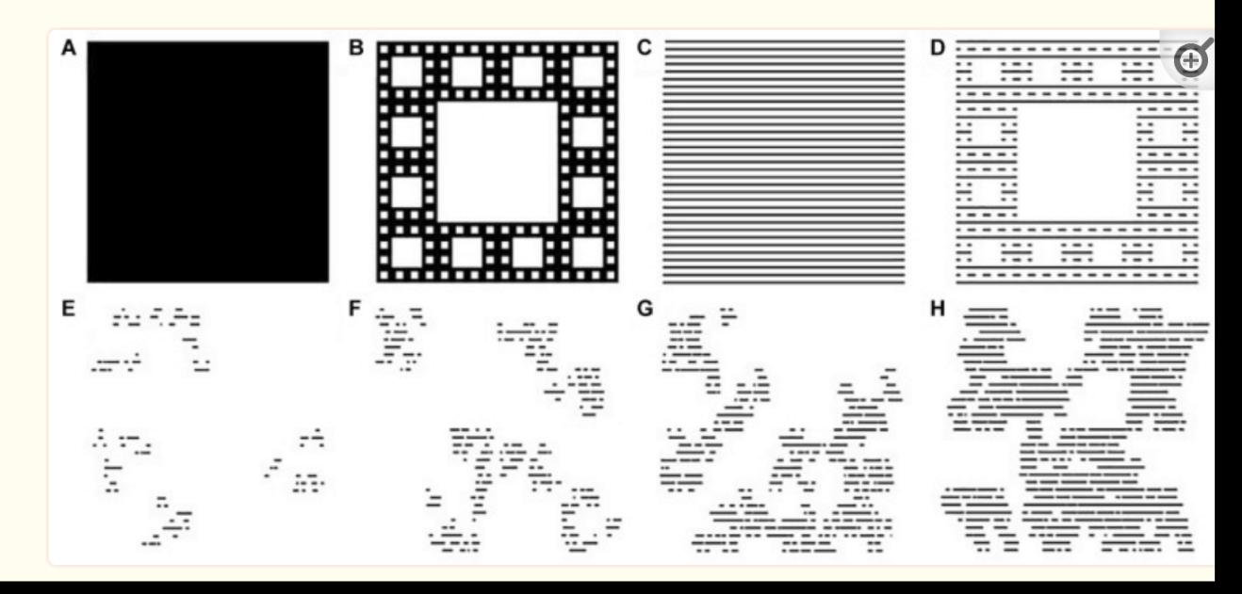

* Studies on fractal tree designs showed that ratings of pattern complexity, engagement, and preference increase with fractal complexity or D-value
* if the goal is to optimize the engagement, preference, refreshment, and relaxation qualities of the fractal design across participants, then a pattern with mid-high D-value would provide this optimal balance
* Relaxation and refreshment coincide with lower levels of arousal whereas engagement requires elevated levels of arousal.

* <https://www.ncbi.nlm.nih.gov/pmc/articles/PMC8416160/>

**Characteristic 5: Biophilic design**

Patterns that mimic or are inspired by patterns found in nature that have a calming, restorative effects such as honeycomb geometries or wave ripples, snowflakes, clouds, snail shells, sunflowers

* <https://sussexwildlifetrust.org.uk/news/natures-mood-boosting-patterns>
* Biophilic design can reduce stress, improve cognitive function and creativity, improve our well-being and expedite healing
* Biophilic design pattern 1: Dynamic & Diffuse Light. Leverages varying intensities of light and shadow that change over time to create conditions that occur in nature.
* Biomorphic Forms & Patterns. Symbolic references to contoured, patterned, textured or numerical arrangements that persist in nature
* Complexity & Order. Rich sensory information that adheres to a spatial hierarchy similar to those encountered in nature.
* Dynamic & Diffuse Light pattern is twofold: to provide users with lighting options that stimulate the eye and hold attention in a manner that engenders a positive psychological or physiological response, and to help maintain circadian system functioning.
* Movement of light and shadows along a surface can attract our attention. For example, the dappled light under the canopy of an aspen tree, or the reflections of rippling water on a wall. These patterns tend to be fractals, and the brain is attuned to moving fractals
* <https://www.terrapinbrightgreen.com/reports/14-patterns/>
* Visual connections with nature can reduce stress, and improve mood and self-esteem (van den Berg et al., 2003; Biederman & Vessel, 2006; Fuller et al., 2007; Kahn et al., 2008; Barton & Pretty, 2010)
* COMPLEXITY AND ORDER is characterized by the presence of rich sensory information that is configured with a coherent spatial hierarchy, similar to the occurrence of design in nature. – fractal geometries (shown below)

* <https://earthwise.education/wp-content/uploads/2019/10/Biophilicdesign-patterns.pdf>

**Methods (Parametrization) to create geometric patterns**

* Using cartesian coordinate or polar coordinate system to generate an Islamic geometric pattern (polygon for base geometry + repetition structure)
* <https://papers.cumincad.org/data/works/att/caadria2015_111.content.pdf>

**Summary (what the pattern design should incorporate)**

* Reflective and/or rotational symmetry
* Moderate visual complexity (that is associated with relaxation – lower energy levels)
* Use upward diagonals as the line of direction, as well as horizontal or vertical lines
* Avoid downward V-shapes
* Use biophilic designs (e.g. flower) to evoke feelings of pleasantness and calmness
* Use curved or rounded shapes
* Refer to fractal patterns and geometries for stress reductions

**Other References**

[Visual Patterns: Neuroscience Implications | Research Design Connections](https://researchdesignconnections.com/pub/visual-patterns-neuroscience-implications)